**CTF Challenge: Footprinting**

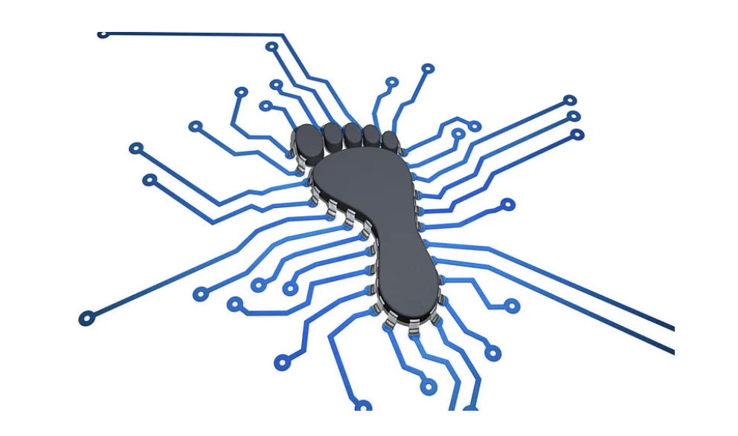

**Why Footprinting?**



Footprinting serves several purposes in cybersecurity:

* **Identifying Vulnerabilities:** By understanding a system's configuration and software versions, you can identify potential security weaknesses that attackers might exploit.
* **Planning Further Actions:** The information gathered through footprinting helps plan subsequent security assessments or penetration testing strategies.
* **Threat Intelligence Gathering:** Footprinting is crucial for gathering intelligence about potential threats. You can identify the target's location, internet presence, and any associated vulnerabilities.
* **Defense Against Attacks:** Understanding an attacker's potential tactics can help you strengthen your own defenses and prepare for potential attacks.

**Footprinting Techniques:**

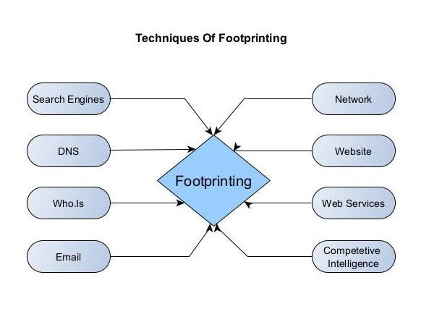

There's a vast arsenal of techniques employed in footprinting:

* **WHOIS Lookup:** This service reveals the domain name registrar and registrant information associated with a website.
* **DNS Records:** Querying DNS records can provide valuable information about the website's server names, IP addresses, and mail servers.
* **Search Engine Techniques:** Using advanced search operators and filtering techniques can help you find relevant information about the target, such as mentions on blogs, forums, or social media.
* **Social Media Investigation:** Checking social media platforms can reveal connections to the target organization, its employees, or potential partners.
* **Passive Network Scanning:** Utilizing tools to scan for open ports on the target's IP address can reveal clues about the services running on the network.
* **OSINT Tools:** Several online tools specialize in gathering information from publicly available sources. These tools can automate some aspects of footprinting.

**Ethical Considerations:**

It's crucial to conduct footprinting ethically and legally. Always respect privacy laws and avoid gathering information that is not publicly available.

# **Capture the Flag (CTF) Challenges**

Flag 1. What can footprinting reveal about a system that helps identify security weaknesses?

Answer: Configuration

Flag Captured

Flag 2. The information from footprinting helps plan what security actions?

Answer: Assessments

Flag Captured

Flag 3. Footprinting is used to gather intelligence about what?

Answer: Threats

Flag Captured

Flag 4. Understanding attacker tactics through footprinting helps strengthen what?

Answer: Defenses

Flag Captured

Flag 5. What domains a whois lookup reveals information about?

Answer: Registrar

Flag Captured